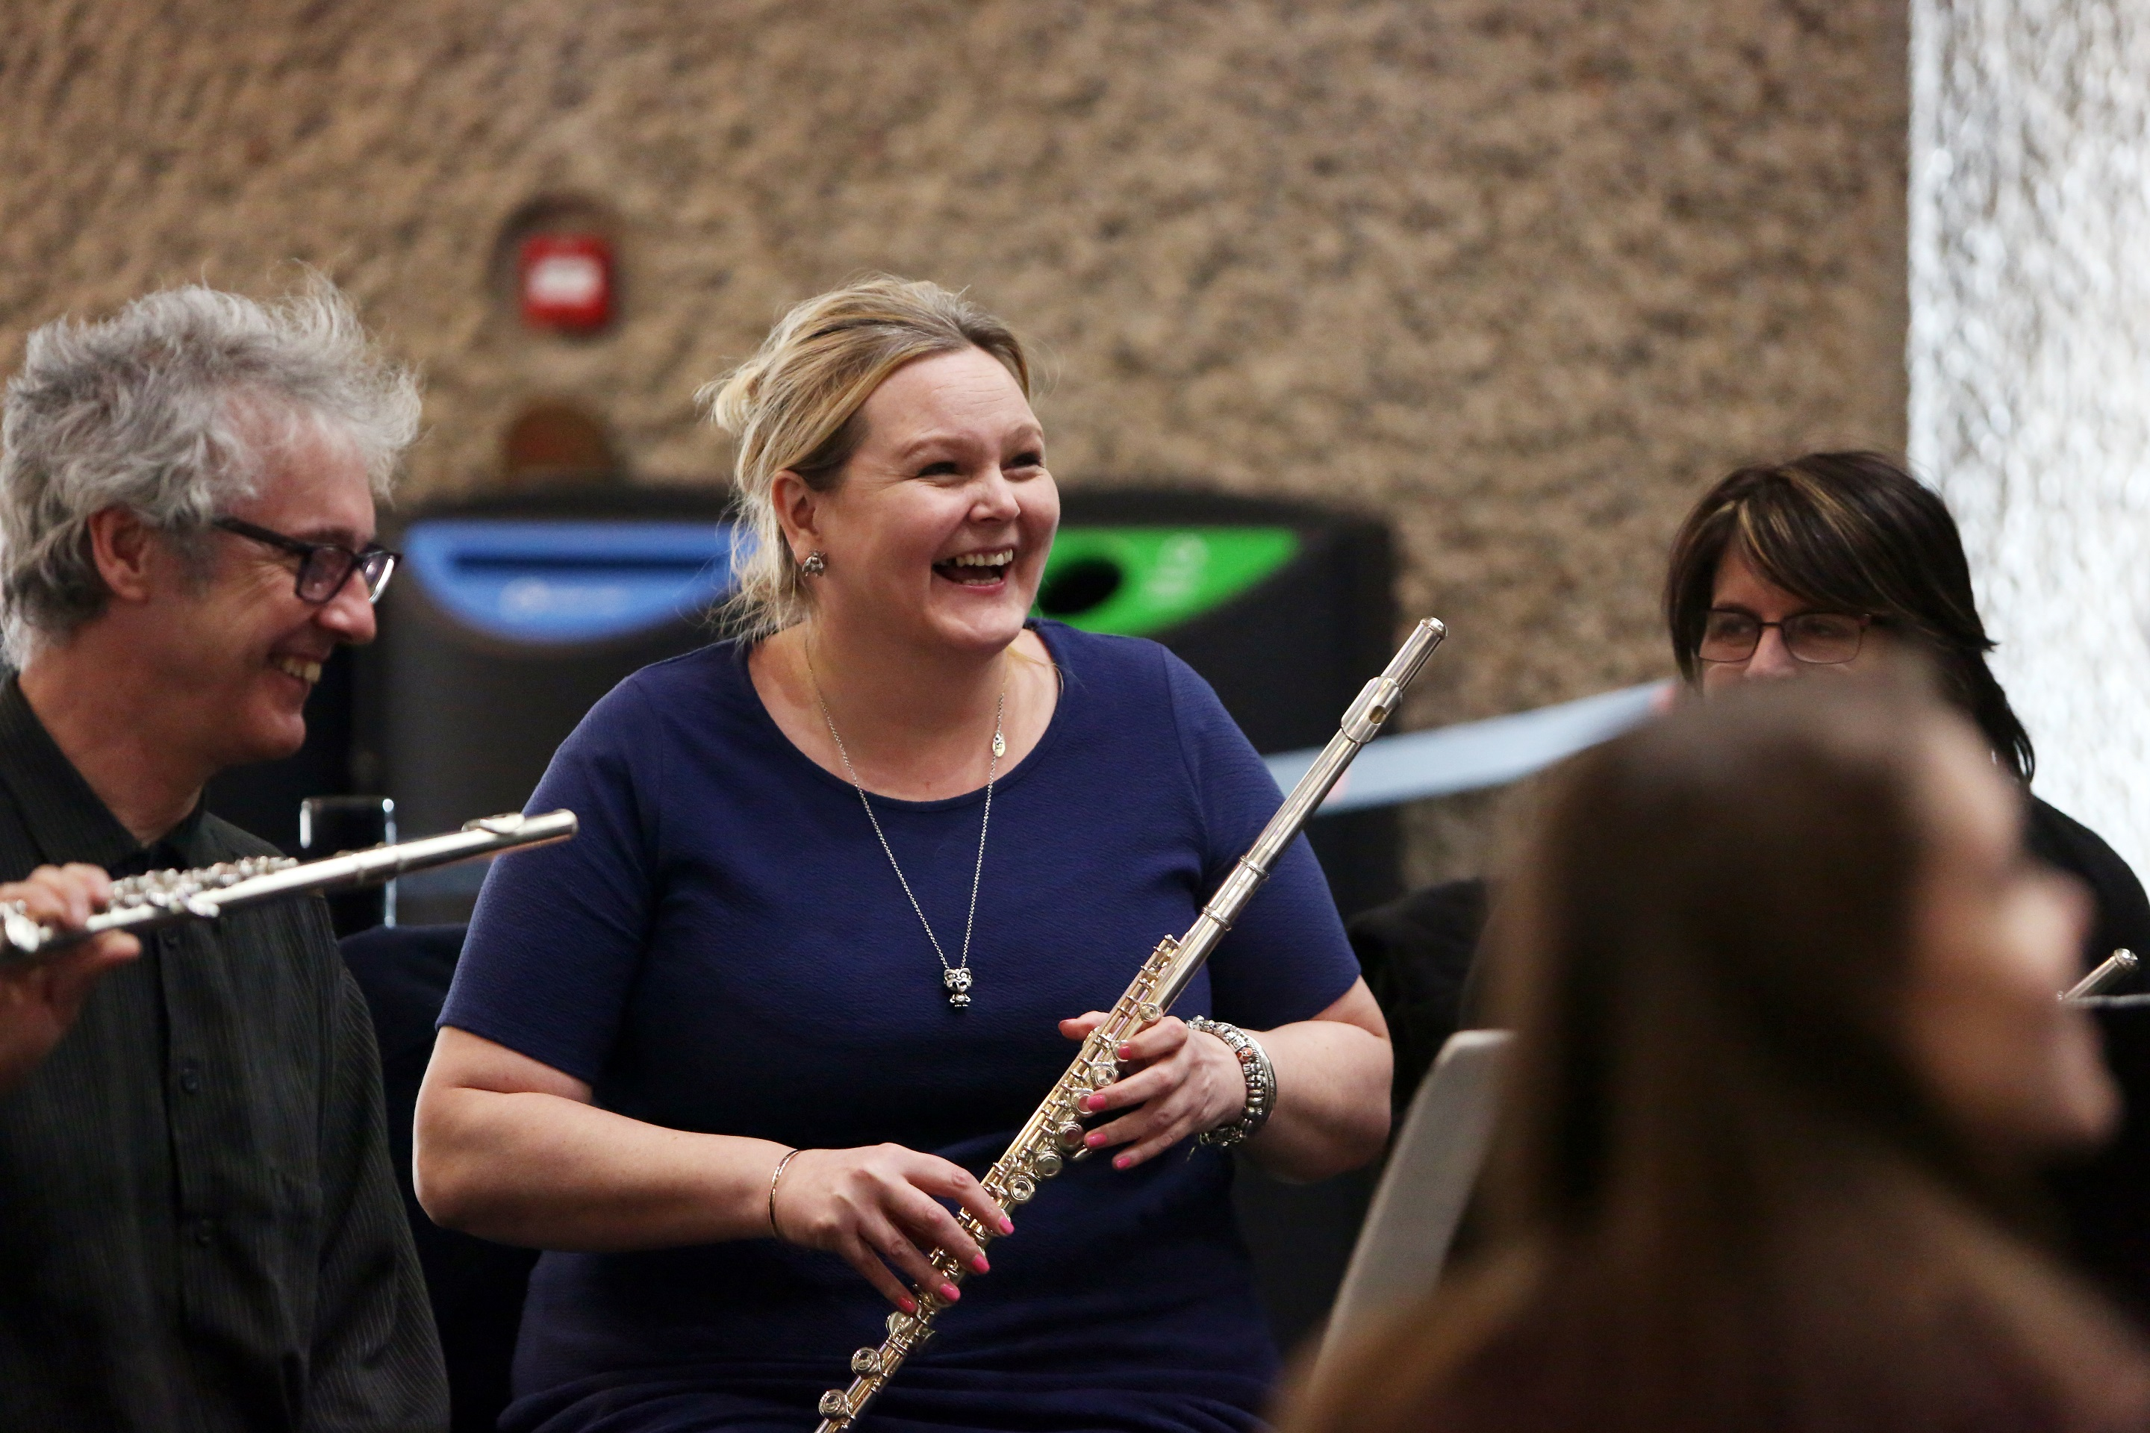

THE PRACTICE OF MUSIC MAKING
2017/18 PROGRAMME BROCHURE

Studying at Trinity Laban
Trinity Laban is a leading conservatoire for professional music and contemporary dance training. Our innovative course provision, exciting performances and ground breaking social inclusion work make Trinity Laban a leader in the advancement of creative artistic practice. As a practice-based institution our programme tutors are active arts and education practitioners as well as being skilled in the design and delivery of high quality training.
Our Higher Education programmes are informed by our work to widen participation in music and dance and include an extensive programme of public engagement work with participants of all ages from children in schools to adult learners.

The Certificate: The Practice of Music Making
The Certificate: The Practice of Music Making (CPMM), is a new one-year programme developed by Trinity Laban in partnership with the Open University. It offers adults with a passion for music the opportunity to develop their practical music making and performance skills. It is delivered through distance (online) learning plus a residential learning week at Trinity Laban’s World Heritage Site home in Greenwich. The Certificate is available as a stand-alone programme, and can also count towards degree study with the Open University.
The Certificate is designed for instrumentalists and singers who participate in any genre of music and there are no auditions to gain entry. It is ideally suited to those who make music regularly in a group or ensemble and who would like to further develop their skills. You might be an army musician, jazz, folk, rock or pop performer, sing in a choir or play in an orchestra, for example. It is suitable for those who have learned to sing or play music without gaining a formal qualification, those who wish to return to music making after a time away and those who have previously studied music and who wish to further develop their performance skills.
As the programme is largely delivered as distance learning, the Certificate offers an accessible opportunity for those who require flexibility in where and when they study. Please note that you need to be an active musician who plays an instrument or sings regularly to complete this programme as putting new ideas and skills into practice is an important aspect of the learning process.

Is the Certificate: The Practice of Music Making for me?
- YES, if you wish to develop your knowledge and understanding of musical practice, rehearsal, communication and creative expression
- YES, if you play an instrument or sing, in any genre, and make or perform music regularly with others

- YES, if you are willing to commit to a formal, ‘bite size’ programme of degree level study, requiring 16-18 hours per week, with written and recorded assignments
- NO, if your primary interest is in developing technical skill on your instrument or voice. The Certificate course does not include instrumental or vocal tuition
- NO, if you make music using technology (only) or are not committed to regularly making music with other musicians, as this would exclude you from elements of the course

About the Programme
The Certificate: The Practice of Music Making is a 60 credit Level 6 higher education qualification. This is equivalent to 50% of the final year of a degree programme, in terms of level and time commitment. On successful completion, students enrolled with the Open University can transfer 60 credits at Open University Level 3 towards degree or further study.

Programme Content
The programme will support you to develop your practical skills, knowledge and understanding of individual musical practice, ensemble music making and musical performance. It does so by exploring a range of ideas and approaches developed by other musicians, before applying these to your own music making. Please note that the programme does not include specific tuition on your instrument or voice but focuses on transferable musical skills relevant across genres and disciplines.
Areas studied will include:
- evaluating and refining your own performances
- exploring approaches to practice, preparation and performance
- examining communication skills, such as in rehearsing and making music with others
- investigating creative technologies in music making
- looking at how to plan performances and develop an audience

How will I learn?
The programme consists of 22 online units. Each provides reading and listening materials to reflect upon, exercises and ideas to take into your personal practice. Throughout the programme, you will be asked to record your own musical development through the use of a reflective journal and occasional audio recordings. This process will not require specialist audio equipment – a mobile phone or tablet, for example, may be an adequate recording device.
The residential learning week at Easter will allow you to further develop your practical skills by making music with others on the course, taking part in workshops, masterclasses, lecture recitals, discussion groups and more.
You will be set four assessed assignments and a personal project, which you must pass to gain the Level 6 (Level 3 OU) Certificate qualification. These will require you to demonstrate critical engagement with programme materials as well as wider research and listening in related subjects.

You will be asked to describe how you have applied concepts and theories to your own musicianship, and with what result. You will not be assessed upon your performance ability, but on how you have engaged with and synthesised musical ideas. Assignments will be supported by regular online tutorials with a member of Trinity Laban staff, including group discussion with other students.
As a Higher Education programme, offered largely through distance learning, this programme requires motivation, intellectual curiosity, critical self-awareness and the ability to learn independently. It aims to be stimulating, highly creative and adaptable, allowing each student to pursue their own musical aspirations.

Programme Outline
- One year of part time study requiring c. 16-18 hours per week.
- Twenty two units of distance (online) learning curriculum undertaken between October 2017 and May 2018.
- Weekly reading, listening and practical tasks to enable you to apply new ideas to your own music making, alone and with others.
- Online group tutorials and discussion forums.
- A residential learning week in Greenwich, London, during April 2018, where you will further develop practical skills and make music with others on the programme.
- Four written assignments and a personal project submitted with associated audio material.

Residential Learning Week
The residential learning week is an immersive practical course for all students running Friday 6 April – Wednesday 11 April 2018 (inclusive).
Based at King Charles Court, home to Trinity Laban’s Faculty of Music and part of the Maritime Greenwich World Heritage Site, the residential will provide opportunities to apply your learning through practical activities alongside other students of the programme. Led by an internationally acclaimed teaching team from Trinity Laban and the Open University, the week will include ensemble based music making, tutorials, lecture recitals and workshops, leading up to an informal performance at the conclusion of your time in Greenwich.
Accommodation for the residential learning week, as well as breakfast, lunch and dinner are provided within the programme fee.

Assessment
You will receive regular and on-going feedback from staff through tutorials and discussion forums. Formal assessment will take place through four written assignments and a personal project with associated audio material uploaded via the Virtual Learning Environment. Support for students is provided.

By the end of the programme as a student you will:
- have increased your understanding of your own music making by exploring a range of musical materials and reflecting on your own practice;
- have explored the musical ideas and practices employed by a range of musicians;
- be able to apply these concepts to your own performance, practice and rehearsal;
- have a greater understanding of the practical skills required to produce successful performances;
- have gained knowledge, understanding and skills that support you to continue to improve your music making beyond the lifetime of the programme; and
- have gained a Higher Education Certificate worth 60 credits at Level 6 (FHEQ). This may be used to gain access to further opportunities for study and, through the collaborative partnership established between Trinity Laban and The Open University, to contribute towards Open University degree programmes (OU Level 3). Please visit The Open University website for further information.

Learning Resources & Support
Trinity Laban’s programmes are supported by Moodle, our virtual learning environment. All CPMM students will have access to the award-winning Jerwood Library’s online holdings - e-journals, online music catalogues and a range of other e-learning resources. Where possible, reading list texts for this programme will be available as e-books. Students will also have access to the conservatoire’s onsite music technology resources, (during the residential study period only) and to MS Office 365. You will be assigned a Personal Tutor to help navigate the programme and the support of the Student Union is also available.
Trinity Laban has considerable experience in supporting students with a range of disabilities including sensory impairment, neuro-diverse conditions, mental health problems, long-term illness and mobility difficulties. Trinity Laban invites disabled applicants to contact the Disability Coordinator to discuss any particular requirements you may have in relation to your enquiry, or application. Please email us at admissions@trinitylaban.ac.uk for further information.
Students enrolled with the Open University are able to continue to access the OU StudentHome online student portal while studying for the Certificate: The Practice of Music Making. OU students will also have access to the Arts Student Support Team, where they can get help with any queries relating to their OU studies.

Teaching Staff
Curriculum content for the Certificate: The Practice of Music Making has been devised and developed by the staff of both Trinity Laban’s Faculty of Music and the Open University, drawing upon their world class subject expertise and professional experience.
A detailed tutor list for the residential study period will be provided to students in early Spring 2018, and will also be available via the Certificate: The Practice of Music Making web page.
https://www.trinitylaban.ac.uk/study/music/certificate-the-practice-of-music-making

Applying to the Programme

Requirements
The Certificate: The Practice of Music Making is an open access course, with no formal entry requirements. As a Level 6 qualification, however, the Certificate builds on previous taught and/or experiential learning that will have provided you with an introduction to study in music and preparation to study at degree level.
Applicants who have not studied at university level before, or whose university-level study is not recent, are strongly advised to consider undertaking study at Level 4 or 5 before commencing study for the Certificate in the Practice of Music Making (Level 6). The Open University offers learning modules in music at Level 5 (OU Level 2) which specifically support skills development in reading, writing, understanding music notation and in analysing music.

Potential students are advised that, in order to complete the programme successfully, you will be required to:
- engage with musical knowledge and ideas in both intellectual and practical contexts. This means undertaking independent research and listening, exploring a range of repertoires, analysing musical material and engaging with theoretical concepts both within familiar and unfamiliar contexts.
- demonstrate the ability to synthesise ideas, construct arguments and propose your own solutions, communicating your thinking clearly in the form of essays, spoken and online discussion. You should be willing to consider your own musical performance in a wider social and cultural context, to challenge their own practices and engage with others, online and in person.
- be actively involved in practical music making, including some form of music making with others (e.g. playing in a band, singing in a choir, rehearsing as a duet) for the duration of the programme. If you are not already involved in music making with others, you will need to find opportunities to do so. Guidance and a list of music-making organisations which may offer appropriate opportunities for individuals is available from the programme team. You will be asked to describe your current and/or planned music making within the personal statement that forms part of the online application to the programme. You will be contacted
if the Programme Leader is concerned that these plans will not meet the learning requirements.
- have a good working knowledge of music and familiarity with music notation. No formal prior qualification in music is required and students who have played an instrument, or sung in an ensemble or group are likely to have acquired the knowledge and experience needed. The programme is flexible to embrace music making in a range of genres, including those that are not widely notated and that use, for example, chord charts rather than stave notation. However, some online units do require basic use and understanding of notational conventions such as:
  - common note-values, and equivalent rests, and their most usual rhythmic groupings
  - time signatures
  - pitches and their positions on the stave (treble and bass)
  - the most common scales, keys and key signatures (major and minor, with up to four sharps and flats)
  - common intervals and chords (triads)
  - Students who feel less confident in these aspects of music theory are encouraged to take the Open University’s free, online course ‘An Introduction to Music Theory’ in preparation for study towards the Certificate: The Practice of Music Making. This can be found at the Open University’s OpenLearn website.
- demonstrate excellent communication and interpersonal skills, including excellent written and spoken English. Applicants who are unsure if their English language skills are at a level sufficient to study on the CPMM programme are invited to visit the Open University’s resource ‘Is my English good enough?’ http://www.open.ac.uk/courses/do-it/english-skills. A range of other OU skills development diagnostic tools are available at Skills for OU Study http://www2.open.ac.uk/students/skillsforstudy/index.php
- have access to a computer or laptop with reliable internet access as all study materials and activities are accessible via a web browser. Other computer-based activities required during study on this programme include word-processing, downloading resources, taking part in online forums, sending and receiving mail, submitting files to Trinity Laban for assessment, and understanding the essentials of computer security. Applicants unsure if their IT skills are at a level sufficient to study on the CPMM programme are invited to visit the Open University’s Computing Skills resource pages http://www2.open.ac.uk/students/skillsforstudy/computing-skills.php. It should be noted that, while some online resources may be accessible via a Smartphone, such a device is unlikely to be sufficient for the full programme of learning and a computer or laptop is needed.
- be able to make digital audio recordings using a mobile phone or other recording device, that can be transferred to a computer. Advice about making, saving, sharing and uploading audio files will be provided following enrolment.

Applicants who are in any doubt about their suitability for study on the programme are encouraged to seek direct guidance from the programme team.
Timeline (for entry in October 2017)
- Email admissions@trinitylaban.ac.uk to enquire or receive application details.
- Please contact us if you have any queries in relation to your application.
- Confirmation of places offered to students by email. Applications remain open with places offered on a first come, first served basis to those who meet entry requirements.
- May 2017 – Student Finance applications open. For up-to-date information please visit https://www.gov.uk/apply-for-student-finance/how
- August 2017 – Online enrolment opens for those who have accepted a place on the course.
- Tuesday 29 August 2017 – Deadline for applications.
- Saturday 16 September 2017 - Online induction commences.
- Saturday 7 October 2017 – Programme start date.
- Friday 6 – Wed 11 April 2018 Residential Learning Week.

Application Process

All applications must be made via UCAS Conservatoires.
https://www.ucas.com/ucas/conservatoires/ucas-conservatoires-apply-and-track
As well as providing information about any prior qualifications you hold, you are asked to attach a personal statement, outlining any other relevant experience, your reasons for wishing to enrol on the programme and your current or planned musical activity. The UCAS application system also asks for the names of two referees, who if contacted would be willing to provide a reference for you.
There is no audition for the Certificate: The Practice of Music Making programme.
A standard application fee of £24 applies for applications for study commencing in 2017.

Validation
The Certificate: The Practice of Music Making is validated by Trinity Laban Conservatoire of Music and Dance (Summer 2016) and delivery is subject to achieving minimum enrolment numbers.

2017 Fees (All students)

Fees for 2017 Entry
Certificate: The Practice of Music Making  (including residential course, accommodation and meals) | £3,350

Payment of Fees
Payment of fees can be made in full or in three equal instalments due on the following dates:

Date Payment

Sept 5 2017 Payment 1
Dec 9 2017 Payment 2
Feb 3 2018 Payment 3

Payment is made via Trinity Laban’s online web payment system upon acceptance of offer of a place and prior to enrolment.

http://www.trinitylaban.ac.uk/students-staff/online-payments

Payment Terms and Conditions
Our standard programme terms and conditions apply, a copy of which is available on the Trinity Laban website. http://www.trinitylaban.ac.uk/about-us/policies-and-freedom-information/disclaimer
This does not affect your rights under the Consumer Rights Act 2015.

Further Information

Contact Us
If you require further information or would like to ask a question about this programme, you may contact the Admissions team at Trinity Laban at the following email address:
admissions@trinitylaban.ac.uk

Frequently Asked Questions
You may also find it useful to visit our FAQs section on the Certificate: The Practice of Music Making web pages which contains answers to many frequently asked questions about the progamme.
https://www.trinitylaban.ac.uk/study/music/certificate-the-practice-of-music-making/faqs

