HOW MOVEMENT WORKS

INFORMATION PACK

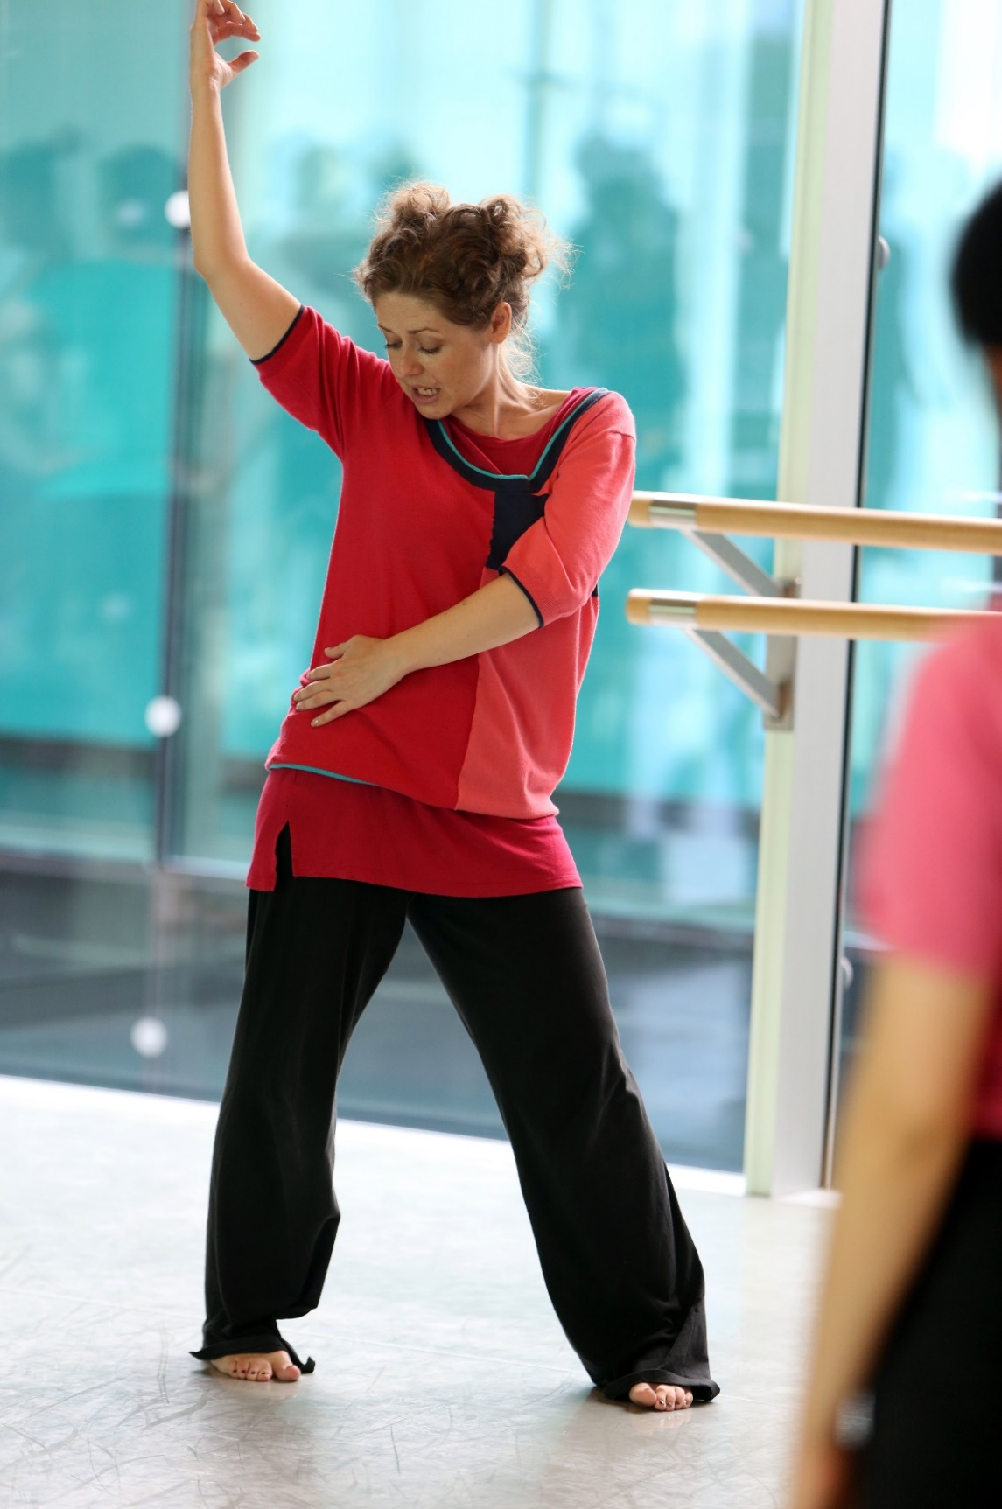

Dear Course Participant,

How Movement Works is a great chance to be fully immersed in dance and movement for a week with us here at Trinity Laban Conservatoire of Music & Dance.

We hope the following information will provide you with everything you need to know concerning the intensive this summer. We are looking forward to welcoming you to the Laban Building. The mix of people from different cultures, movement backgrounds and different ages will make for a very exciting and unique experience investigating choreological themes.

We look forward to meeting you in July.

Best Wishes,

Alison Gee (Alliey)
Head of Community and Professional Development
Learning and Participation (Dance Programmes)

ABOUT TRINITY LABAN

Trinity Laban is the UK’s only conservatoire of music and contemporary dance. Leaders in music and contemporary dance education, we also provide exciting opportunities for the public to encounter dance and music, and access arts health programmes. The unequalled expertise and experience of our staff and our world-class facilities are housed in landmark buildings.
Trinity Laban is one of Europe's leading centres for the training of professional contemporary dance artists. At the heart of South East London's thriving arts community, Trinity Laban is a creative and cosmopolitan community of performers, choreographers, teachers, designers and researchers, and is acknowledged internationally as a leader in the contemporary arts.
With one of the largest teams of specialist contemporary dance artist teachers in the world, our world-class facilities include a 300-seat theatre, studio theatre and outdoor theatre, 13 purpose-built dance studios and an extensive library and archive.
At Trinity Laban we believe that contemporary dance has a vital part to play in everyone's lives. Our unique mix of energy and creativity advances the dance art form and fuels the dance world, connecting people to the exhilarating possibilities that dance offers. Our links with the professional dance world, local communities and other arts organizations ensure that an experience at Trinity Laban will be a rich and rewarding one.

FINDING THE LABAN BUILDING

Address: Laban Building, Creekside, Deptford, SE8 3DZ
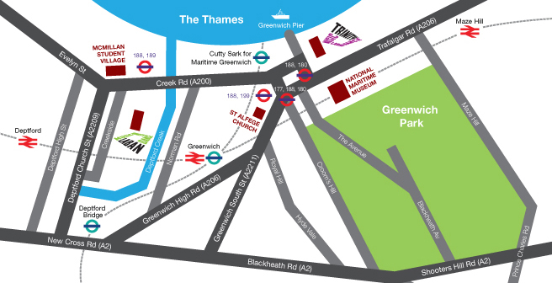

The most useful places to check information on transport routes, fees and travel times are:
Transport for London and National Rail Enquiries

Public Transport Payment Methods
- Contactless Cards: You can use your contactless payment card to travel on bus, Tube, tram, DLR, London Overground, TFL Rail and most National Rail services in London.
- Oyster Cards: Oyster is a plastic smartcard which can hold pay as you go credit or travel cards which are valid for a set time period. You can use an Oyster card to travel on bus, Tube, tram, DLR, London Overground, TFL Rail and most National Rail services in London.

By Docklands Light Railway
The Docklands Light Railway (DLR) offers a frequent service to Cutty Sark station or Greenwich Station which is a few minutes’ walk from the Laban Building. The DLR joins to the London Underground at:
- Monument / Bank (Central, Circle and District Lines)
- Canary Wharf (Jubilee Line)
- Stratford (Central Line, TFL Rail).
- West Ham (Jubilee, District, Hammersmith & City)

At Cutty Sark turn right out of the station and right again on to Creek Road. Take the second left after the bridge onto Creekside and the Laban Building is on your left. (10 min walk).

From Deptford Train Station
Leave the train station and turn right onto Deptford High Street. Walk down the road until you can see HSBC Bank on the left. Turn left down Griffin Street so that HSBC Bank is on your right. Walk to the end of the road (past Deptford Lounge – a golden building and Wave Lengths Leisure Centre on your left) and turn left onto Deptford Church Street. Walk as far as the zebra crossing and cross the road. Continue in the same direction until you reach Berthon Street on your right. Walk to the end of Berthon Street and you will be able to see the Laban Building directly in front of you.

By Bus
Bus numbers 47, 188 and 199 stop near the Laban Building.

By Road
From Central London: Take the Old Kent Road to its end in New Cross then follow the A2 until you reach the junction for Deptford Church Street. Turn left and continue to the mini roundabout, then turn right into Creekside. From M2/M25: Follow the A2 until you reach the turning for the junction for Deptford Church Street. Turn right and continue to the mini roundabout, then turn right into Creekside. There is limited parking at the Laban Building but there is also on street parking. We have cycle racks at the rear of the building and also a number of disabled parking spaces to the front of the building.

INTENSIVE WEEK INFORMATION
Registration
Please aim to arrive at the Laban Building at 10.00h on Monday for registration.

At registration we will give you a security card to access the building. A tour will also be organised in the morning to orient you to our building, studios and changing facilities. Any security passes lost or unreturned at the end of the course will warrant a £10 fine.

Classes
Please be sure to bring your dance clothes with you. Changing rooms and shower facilities are available for all participants to use. If you wish to shower you should bring a towel with you. Lockers are located along each of the main corridors, please bring a padlock and key of your own if you wish to use one. In each studio there are storage areas should you wish to keep your belongings with you throughout the day.

What to wear
Participants are advised to wear what they normally wear in dance classes; a collection of tight and loose/ comfortable fitting clothing and extra layers and warmth. Participants should expect to do classes in bare feet.
Heath and Well Being
Please let your teacher know if you have an illness or any injuries which they should be aware of during your participation in classes. If you sustain an injury or feel unwell at any point during the intensive, please let a member of the teaching / administrative team know. There are First Aiders on site throughout the intensive as well as a physiotherapist to treat injuries.

Internet Access
There is guest Wi-Fi access during your time in the Laban Building. You will find wifi login details on notices at the Box Office. You are also welcome to use the computers in the Laban Building Library.

Laban Building Café
The Café at the Laban Building sells a range of food including hot lunches, salads, sandwiches and snacks. You are welcome to bring your own food to eat in the café too. There are also some local shops on Creek Road in the event the café is closed.

ACCOMMODATION
This is a non-residential course. During the summer months accommodation is likely to be busy in London and we advise participants to plan where to stay well in advance.

For information about local accommodation please visit the Greenwich Tourist Information website: http://www.visitgreenwich.org.uk/.

TRINITY LABAN HEALTH
The Trinity Laban Health team are dedicated to encouraging health and well-being, preventing injury and providing effective rehabilitation. They provide an extensive range of complementary therapies that you may wish to benefit from whilst attend the How Movement Works course.

To find out more visit https://www.trinitylaban.ac.uk/trinity-laban-health

LABAN BUILDING LIBRARY AND ARCHIVE
During your spare time at the Dance Summer School we encourage you to make the most of the Laban Building’s Dance library. It offers the largest and most varied open access specialist research collection on dance and related subjects in the UK, covering many aspects of dance in a variety of formats and languages. You are also welcome to use the library’s computers, internet, and many of its resources.
For further information, see http://www.trinitylaban.ac.uk/student-experience/facilities/faculty-of-dance/laban-library-archive

When is the Dance library open?
Weekdays: 10.00-18.00
Weekends: 11.00-15.00 (this may be subject to change)

What do I need to get started?
From the above link, use the Laban library catalogue to find books, videos, DVDs, CDs, journals, theses, etc. Once in the Library, you can search QuickSearch for access to electronic journals as well.

How do I find things on the catalogue?
- Enter the author or choreographer (surname, then forename) or the title of the book, video, journal you want to find.
- Click on the Title drop-down arrow to change where you look to Author to look for a book by an author or dance piece by a choreographer or to Subject to look for items about someone or something.
E.g. Forsythe, William as an author will retrieve items by him as a choreographer. As a subject, it will find items about him.

How do I locate what I’ve found on the catalogue in the Library?
- Let’s say you are looking for Fifty Choreographers by Martha Bremser.
- You have entered the author or title and a single line displays the search result. Click on the title for more information.
- Holdings says which collection it is in Library - Dance Books (nearer) or Library - General Books (further up the library), the shelf location and number available.
- The prefix, LAB, indicates that it is in the Dance Books; GEN = General Books
- The suffix, BRE, will help find it on a particular shelf, if there are lots of items shelved at that number.

Apart from LAB for Dance Books, what other prefixes and collections are there? The main ones are:
CD | CDs shelved, by the computers
CUT | Cuttings – from newspapers and similar publications
GEN | General Books
JOU | Journals
LAB | Dance Books. Spine labels start with L then a number.
TH | Theses, shelved at the top of the Library
TUT | Tutor shelves, by the computers
VID | Videos and DVDs, shelved by the computers

Where can I get help?
Staff at the Service Desk can help you find books, journal articles, DVDs, CDs and web resources, etc. We can also assist with equipment or computer problems. If they cannot answer these, the questions will be forwarded to other support staff.

