SUMMER SCHOOL 2020 INFORMATION PACK

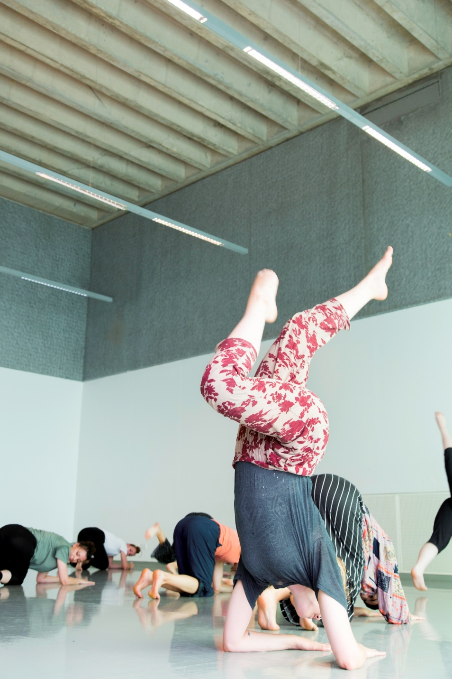

DANCE SUMMER SCHOOL 2020 INFORMATION PACK

Dear Course Participant,
Welcome to Trinity Laban’s Dance Summer School!

The following information should provide you with helpful information for our Dance Summer School.

Dance Summer School is a great chance to be fully immersed in dance and movement. We hope summer school will be a rich and inspiring experience for you. Alongside the daily classes, you will be able to find out about full-time training, look after your body through additional health and well-being activities, and watch free programmed performances as well as making new friends, socialising and relaxing!

The course attracts an international community from all around the world, and we’re always excited to see people from many different dance backgrounds.

We aim to make you feel as welcome and supported as possible! Should you have any questions prior to the start of the course please refer back to this Information Pack or see the Frequently Asked Questions. If you can’t find an answer there you can contact our team on dancesummerschool@trinitylaban.ac.uk.

We hope that you have a great time with us this summer and look forward to warmly welcoming you!

Best Wishes

Alliey Gee
Head of Community and Professional Development
Learning and Participation (Dance Programmes).

ABOUT TRINITY LABAN

Trinity Laban is the UK’s only conservatoire of music and contemporary dance. Leaders in music and contemporary dance education, we also provide exciting opportunities for the public to encounter dance and music, and access arts health programmes. The unequalled expertise and experience of our staff and our world-class facilities are housed in landmark buildings.
Trinity Laban is one of Europe's leading centres for the training of professional contemporary dance artists. At the heart of South East London's thriving arts community, Trinity Laban is a creative and cosmopolitan community of performers, choreographers, teachers, designers and researchers, and is acknowledged internationally as a leader in the contemporary arts.
With one of the largest teams of specialist contemporary dance artist teachers in the world, our world-class facilities include a 300-seat theatre, studio theatre and outdoor theatre, 13 purpose-built dance studios and an extensive library and archive.
At Trinity Laban we believe that contemporary dance has a vital part to play in everyone's lives. Our unique mix of energy and creativity advances the dance art form and fuels the dance world, connecting people to the exhilarating possibilities that dance offers. Our links with the professional dance world, local communities and other arts organizations ensure that an experience at Trinity Laban will be a rich and rewarding one.

TRAVELLING TO LONDON FROM THE AIRPORT
London has five international airports; Heathrow, Gatwick, Stansted, Luton and City Airport, each less than an hour away from the city centre.

Heathrow Airport
Heathrow Airport is located 12 miles west of the city. The public transport options from Heathrow are:
The Heathrow Express The fastest link between Heathrow and London. Non-stop trains run to Paddington Station every 15 minutes. Tickets can be bought on the internet or at the station.
Heathrow Connect A stopping service from Heathrow to Paddington via stations in west London. Trains run every 30 minutes.
London Underground This is the most cost-effective rail route into London, though it will take longer. Piccadilly Line trains run from all terminals every few minutes.

Gatwick Airport
Gatwick Airport is located 30 miles south of central London. The public transport options from Gatwick are:
Gatwick-Express A non-stop train service to London Victoria running every 15 minutes.
Southern Trains Southern train services to London Victoria via East Croydon and Clapham Junction. These run four times an hour. Thames Link Services to London Bridge and St Pancras International run four times an hour.

Stansted Airport
Stansted Airport is located 34 miles northeast of central London. The public transport options from Stansted are:

Stansted Express Run fast, frequent trains, departing every 15 minutes. Average journey time is 46 minutes to Liverpool Street and 35 minutes to Tottenham Hale.
National Express coaches National Express offer regular coaches from Stansted Airport to Stratford and other London locations.

Luton Airport
Luton Airport is located 35 miles north of central London. Trains run regularly from Luton Airport Parkway station; find more information here: http://www.london-luton.co.uk/to-and-from-lla/going-south-beyond-london

London City Airport

London City Airport is situated in East London and has its own station on the Docklands Light Railway (DLR). To plan your journey from the station please visit https://tfl.gov.uk/

FINDING THE LABAN BUILDING
Address: Laban Building, Creekside, Deptford, SE8 3DZ

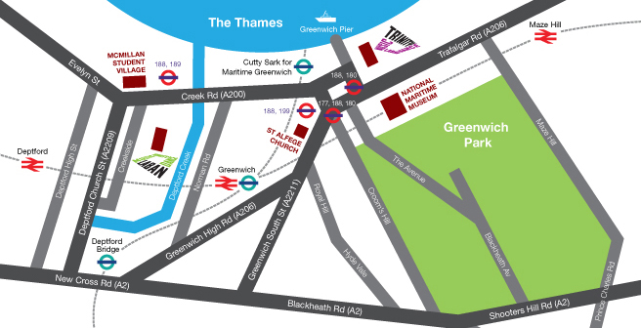

The most useful places to check information on transport routes, fees and travel times are Transport for London and National Rail Enquiries

Public Transport Payment Methods
- Contactless Cards: You can use your contactless payment card to travel on bus, Tube, tram, DLR, London Overground, TfL Rail and most National Rail services in London.
- Oyster Cards: Oyster is a plastic smartcard which can hold pay as you go credit or travel cards which are valid for a set time period. You can use an Oyster card to travel on bus, Tube, tram, DLR, London Overground, TfL Rail and most National Rail services in London. Find out more online at https://tfl.gov.uk/fares-and-payments/

By Docklands Light Railway
The Docklands Light Railway (DLR) offers a frequent service to Cutty Sark station which is a few minutes’ walk from the Laban Building. The DLR joins to the London Underground at:
- Monument / Bank (Central, Circle and District Lines)
- Canary Wharf (Jubilee Line)
- Stratford (Central Line, TFL Rail).
- West Ham (Jubilee, District, Hammersmith & City)

At Cutty Sark turn right out of the station and right again on to Creek Road. Take the second left after the bridge onto Creekside and the Laban Building is on your left. (10 min walk).

From Deptford Train Station
Leave the train station and turn right onto Deptford High Street. Walk down the road and turn left at Griffin Street, walking past Deptford Lounge (a golden building) and Wave Lengths Leisure Centre on your left. Turn left onto Deptford Church Street. Walk as far as the crossing and cross the road. Continue in the same direction until you reach Berthon Street on your right. Walk to the end of Berthon Street and you will be able to see the Laban Building directly in front of you.

By Bus
Bus numbers 47, 188 and 199 stop near the Laban Building.

By Road
From Central London: Take the Old Kent Road to its end in New Cross then follow the A2 until you reach the junction for Deptford Church Street. Turn left and continue to the mini roundabout, then turn right into Creekside. From M2/M25: Follow the A2 until you reach the turning for the junction for Deptford Church Street. Turn right and continue to the mini roundabout, then turn right into Creekside. There is limited parking at the Laban Building but there is also on street parking. We have cycle racks at the rear of the building and also a number of disabled parking spaces to the front of the building.

DANCE SUMMER SCHOOL INFORMATION
Registration and Tours: 9.30– 11.00h
You will need to arrive at the Laban Building from 9.30 – 11.00h on Monday 20 July. Please check your emails, as the registration may be staggered to manage the arrival of all participants.

Please bring a copy of your booking confirmation email with you.

There will not be a session 1 on day 1. This time will be focused on welcoming and orientating yourself in the building.

During registration we will give you a welcome pack which will include a security card to access the building and your Dance Summer School timetable. Tours will take place from 9.45 – 11.00h to orient you to our building, studios and changing facilities. Please use this time to check you ID badge is working. If not hand this back to the summer school or security team along with your name. They can fix and return to you at the end of the day. Any security passes lost or unreturned at the end of the summer school will incur a £10 fine.

Session choices
Some classes are different lengths, please check your timetable carefully. It is unlikely that we can accommodate any class swaps, once you have begun classes. We therefore advise that you carefully consider your class style and level to ensure you have an enjoyable two weeks of dance.

DANCE SUMMER SCHOOL TEAM

It’s a friendly environment at Trinity Laban, and Alliey Gee and Kara Coffey from the Learning & Participation (Dance Programmes) team, will be here to support you. We also have three Dance Summer School assistants who are Trinity Laban students. They will be available in class and during the additional activities and will also be living at the McMillan Student Village for the full two weeks. If you encounter any problems at all please alert a member of the team and we will be happy to signpost you to the right help.

Stay up to date
To enable us to keep you informed of important changes or updates throughout the two weeks, we will ask teachers to announce news at the start of classes. We will also post updates on the Dance Summer School noticeboard, which will be pointed out on the tour of the building. Updates may include studio/staffing changes and signup sheets for additional activities. Please make sure that you check the notice board regularly throughout the course.

FACILITIES ON SITE

Changing Rooms and Lockers
Changing rooms and showers are available for all participants to use. If you wish to shower you will need to bring a towel with you. Lockers are also available for you to use, please bring your own padlock if you wish to use one. Lockers are located along each of the main corridors. You should remove all items at the end of summer school. In each studio there are storage areas should you wish to keep your belongings with you throughout the day, however Trinity Laban is not responsible for the loss of any items.

Fuelling up
Laban Building Café is open Monday-Friday, from 08.30h. The Barista & Baker Café at the Laban Building sells a range of food including hot lunches, salads, sandwiches and snacks. You are welcome to bring your own food to eat in the café too if you prefer.

There are free water fountains available throughout the building to help you stay hydrated

Internet Access
We will provide you with a Wi-Fi access code at the start of the course. You are also welcome to use the computers in the Laban Building Library. If you are staying at the McMillan Student Village you will be able to access Wi-Fi there also.

Laban library and archive
During your spare time at the Dance Summer School we encourage you to make the most of the Laban Building’s library and archive. Our library offers the largest and most varied open access specialist research collection on dance and related subjects in the UK, covering many aspects of dance in a variety of formats and languages. You are also welcome to use the library’s computers and internet.

For further information, see http://www.trinitylaban.ac.uk/student-experience/facilities/faculty-of-dance/laban-library-archive

Staff at the Service Desk can help you find books, journal articles, DVDs, CDs and web resources, etc. We can also assist with equipment or computer problems. If they cannot answer these, the questions will be forwarded to other support staff.
WHAT TO WEAR?
Participants are advised to wear a mixture of loose and tight fitting clothing, so teachers can check alignment. Wear what you feel is comfortable and safe to move in. We recommend you bring multiple layers so you can add/remove layers as needed. If you are taking contact improv or flying low, it is advisable that you wear long trousers (within reason) and cover your shoulders to avoid friction burns.

Footwear: Participants attending ballet are advised to wear soft ballet shoes. For Ballet Level 1, socks may be worn at the barre as an alternative if you do not own any. We do not offer pointe work during the course. Participants may wear jazz shoes for Jazz or white soled trainers for Street Dance if they have them. Participants should expect to do all other classes in bare feet.

Additional Equipment
For those enrolled onto Yoga, Pilates classes, mats will be provided. Therabands, balls and blocks will also be available to use during our body conditioning classes. If you wish to bring your own mat you are welcome to do so.

HEATH AND WELL BEING

Please let your teacher know if you have an illness or any injuries which they should be aware of. If you sustain an injury or feel unwell at any point during the course, please let a member of the Dance Summer School team know. There are First Aiders on site throughout the course as well as our health clinic, were you can make an appointment to see physiotherapist to treat injuries. The course is fun but can be physically demanding, so we have programmed morning and lunch breaks to enable participants to rest properly.

Trinity Laban Health
The Trinity Laban Health team provide an extensive range of treatments that focuses on injury prevention, management and effective rehabilitation, with specialism in treating performing artists. We encourage you to use the health facilities at the Laban Building during your time here, all provided in purpose-built treatment rooms. Dance Summer School participants receive a 10% discount during the course. Prices and therapies are subject to change. Current prices available online

Call 020 8305 9479, 020 8305 9482 or e-mail health@trinitylaban.ac.uk to enquire about the discount.

TALKS, WORKSHOPS AND OTHER FUN THINGS!

On arrival you will receive a copy of the extra activities timetable. This is a programme of additional sessions which fit around your classes, taking place at lunchtimes, in the evenings, or early in the morning.

This will also be available on the Trinity Laban website once the programme has been finalised.

The programme will include:
- A performance in the Laban Theatre
- Sessions led by Trinity Laban Health
- Social activities, including a Welcome Reception in the evening on Monday 20 July
- Undergraduate and Postgraduate programme talks
- Sharing’s of the work that has taken place in the studios across the two weeks – Friday

Some activities will have limited capacities and you will be able to sign up for these sessions via the noticeboard.

Spare Time
Classes finish at 17.15 each evening, and there are no classes programmed on the weekend. Please check the extra activities timetable on your first day and sign up to any activities that you are interested in.

For ideas of what to do during the weekend and in your spare time you may wish to take a look at the below websites:
- http://www.visitgreenwich.org.uk/
- http://www.timeout.com/london
- http://www.visitlondon.com/

LOCAL TO LABAN

The Laban Building is situated on Creekside, a 5 minute walk from both Deptford and Greenwich high streets and about a 15 minute walk from Blackheath and New Cross. The local area provides a huge array of shops and entertainment including everything from fine dining to sandwiches and classical music to club nights, plus three weekly markets.

Eating
Greenwich and Deptford offer a number of places to eat and drink. Visit the links below to find out more.

Going Out
For a guide to Greenwich please see http://www.timeout.com/london/things-to-do/greenwich-area-guide
For a guide to Deptford please see http://www.timeout.com/london/things-to-do/deptford-area-guide

Banks NatWest Bank plc, 2 Greenwich Church Street

Supermarket / Food Shopping
- Tesco Metro, Creek Road
- Sainsbury’s Local, Creek Road
- Waitrose, New Capital Quay (just off Creek Road)
- Marks & Spencer Simply Food, 55-57 Greenwich Church Street
- Asda, 5-9 Deptford High Street
- Deptford High Street also has a range of fruit and veg shops, butchers and fishmongers.

Markets
- Greenwich Market: Tuesdays – Sundays, 10am - 5.30pm.
- Deptford Market: Wednesdays, Fridays & Saturdays 9am-5pm.
Dance Wear Shops (Central London)
- Bloch, 35 Drury Lane, WC2B
- Dancia International, 168 Drury Lane WC2
- Capezio, Royal Opera House, 33 Endell Street WC2H
- Freeds, 94 St. Martin’s Lane WC1

Post Office 261-267 Greenwich High Road

Emergencies
In an emergency please dial 999. For medical emergencies please check in with NHS services help line 111

Pharmacies
- Rose Pharmacy: 24 Creek Road, Deptford
- Boots: Greenwich Church Street
- Superdrug: 3 Crescent Arcade, Greenwich

ACCOMMODATION: THE MCMILLAN STUDENT VILLAGE
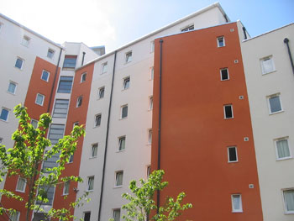
McMillan Student Village, Creek Road, Deptford, London, SE8 3BU
The McMillan Student Village is located just a short walk from the Laban Building and from Greenwich Town Centre. We offer a limited number of rooms for our Dance Summer School participants. The student village offers a safe and comfortable community environment.

The Facilities
- The accommodation comprises of a single room with a bed, wardrobe and study desk.
- Each room has ensuite facilities, including a shower, toilet and sink.
- Each room is on a corridor with the use of a fully fitted shared kitchen with fridge, oven, and microwave. The student village is self-catering – food is not included.
- Bedding, towels and kitchen utensils are provided; bedding and towels will be changed once a week. You may like to bring an extra towel to use in the showers at the Laban Building.
- There are washing machines and drying facilities located at the McMillan Student Village.

Please note it is not possible to book a double room. All rooms are single rooms and must only be occupied by one person.

It is important to note that, as these are halls of residence, there will be other groups residing in the accommodation during the two weeks. This can make the student village fairly busy and very noisy. You are responsible for keeping all areas including kitchens clean and ensuring that all rubbish is removed before you leave. Anything left may incur a charge.

Check in will be from 14.00 - 17.00h on Sunday 19 July. You will be required to vacate the halls of residence by 10.00 on Saturday 31 July.

16 – 18 year olds staying at the McMillan Student Village
The Dance Summer School is primarily designed for adults, however every year we are pleased to welcome young people aged 16 – 18 as they can benefit from the adult environment and level of dance training. We do wish to make clear that all participants, regardless of age, have the independence to come and go as they wish and we do not provide any special supervision for those participants under the age of 18. In the McMillan Student Village, we have Dance Summer School assistants living in during the two weeks but their role is to help in case of emergencies. They do not function in loco parentis, either at the student village or at the Laban Building for the two-week duration.

How to get to the McMillan Student Village
The student village is located on Creek Road, near the Laban Building. It is just a few minutes’ walk between the two locations.

Accommodation Alternatives
During the summer period accommodation is likely to be busy in London and we advise participants to plan where to stay well in advance.

For information about local accommodation please visit the Greenwich Tourist Information website:
http://www.visitgreenwich.org.uk/

