Trinity Laban’s Environmental Policy
Trinity Laban Conservatoire of Music and Dance is a world-leading institution in the education of professional musicians, contemporary dancers, and musical theatre artists. Our international reputation attracts students from throughout the UK and around the world. Delivered by eminent staff in outstanding facilities and sustained by partnerships through the cultural industries, our programmes ensure that graduates are ideally positioned to succeed in the ever changing and competitive fields of the performing arts.
The Conservatoire is a major centre of excellence in the performing arts. We are one of the largest of the UK conservatoires with around 1,200 undergraduate, postgraduate and research students. In achieving excellence in teaching, training and research, Trinity Laban aims to manage its activities, buildings and estates to:
- promote environmental sustainability,
- conserve and enhance natural resources and;
- prevent environmental pollution.
The ultimate goal is to bring about a continual improvement in our environmental performance.
The Conservatoire will comply fully with environmental legislation and officially approved codes of practice, and will make continued efforts to:
- promote sound environmental management policies and practices;
- increase awareness of environmental responsibilities amongst staff and
students;
- work with other agencies to promote appropriate environmental policies;
- implement policies and procedures that contribute to a reduction in the Conservatoire’s carbon footprint;
- maximise the proportion of waste that is recycled and minimise the quantity of nonrecyclable refuse;
- work with its catering contractor to do all we can to source seasonal, local, or sustainable food whenever possible;
- reduce energy consumption, especially energy derived from fossil fuels, in all Conservatoire property;
- minimise consumption of water;
- maintain the grounds and buildings of the Conservatoire in an environmentally sensitive way;
- have regard to environmental factors as far as practicable in respect of the growth of the Conservatoire by, for example, aiming for at least BREAM very good in building project or excellent if feasible, (bearing in mind the historic nature of some of our estate);
- Promote and enhance sustainable procurement;
- encourage modes of transport by staff and students which minimise the environmental impact;
The implementation of this policy will be the responsibility of the Sustainability Working Group and the Finance and General Purposes committee. Both the Sustainability Working Group and the Finance and General Purposes committee will meet at least once each term. The Sustainability Working Group will include relevant staff and student members and will develop a plan for improving environmental performance, with measurable indicators where possible, and will report on its progress annually.
The Head of Estates and Facilities and the Director of Finance and Estates will take responsibility for ensuring that staff and students are involved in a process of continuous environmental improvement.
The policy is fully supported by the Executive Team led by the Principal.
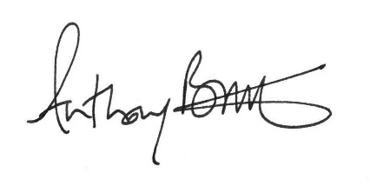
Professor Anthony Bowne
Principal of Trinity Laban
February 2020

