

McMillan Student Village

Accommodation Information (2024/2025)

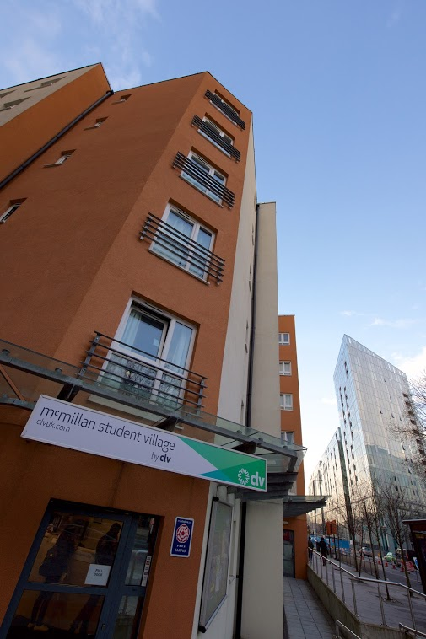

Comprehensive information for students of
Trinity Laban Conservatoire of Music and Dance

McMillan Student Village

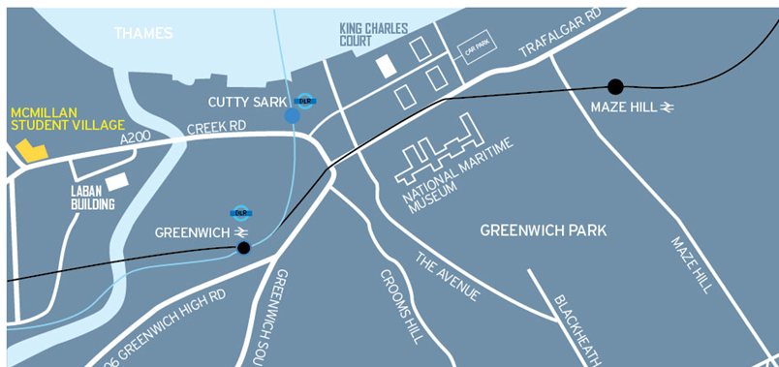
Where is McMillan Student Village?

McMillan Student Village is two minutes’ walk from the Laban building, only about a 15 minute walk from King Charles Court for the Faculty of Music and 20 minutes to Laurie Grove.

What are the transport links like?
- McMillan Student Village is situated within close walking distance of the Cutty Sark and Deptford Bridge DLR as well as Deptford and Greenwich mainline stations offering excellent transport links within 20 minutes to central London. The 47, 188 and 199 buses also stop outside McMillan Student Village.

What facilities are available on-site?
- McMillan Student Village is a purpose built, modern campus with landscaped courtyards. It offers the following on-site facilities to residents:

 | - Bike sheds  - Launderette | - 24 hour security  - Common room
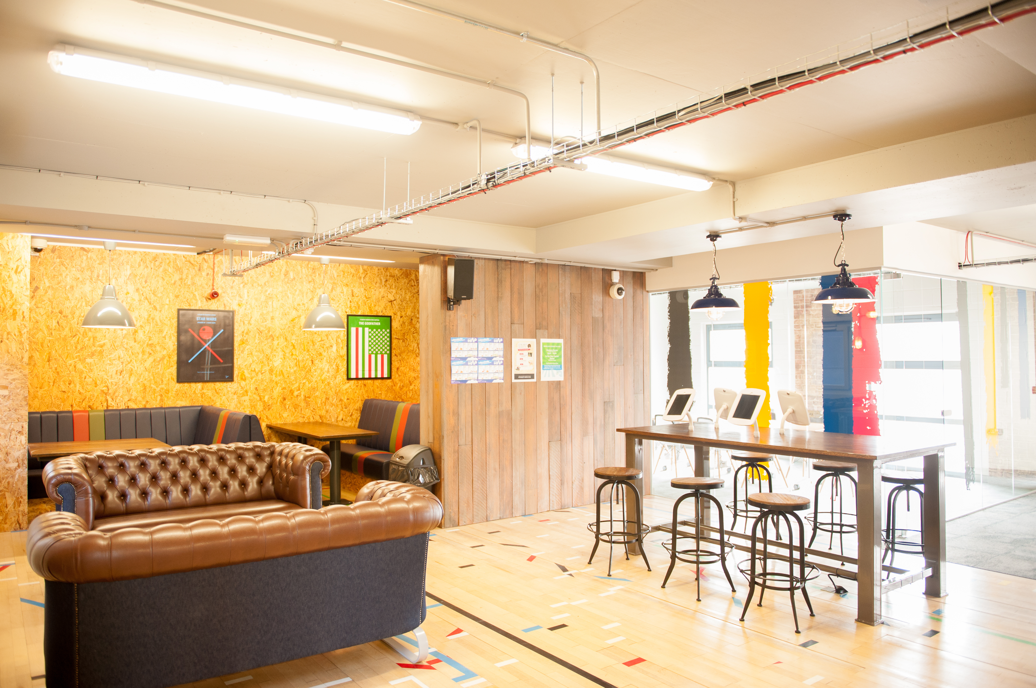

Common Room at McMillan Student Village

What types of rooms are available?
- There are four types of rooms available:
  - Standard Cluster Flats
These are 6 single en-suite bedrooms grouped together with a shared kitchen/diner. We have a particularly large demand for these rooms.

  - Cluster PLUS Flats
These follow the same set up as the Standard Cluster Flats but with a slightly bigger room (still with a single bed).
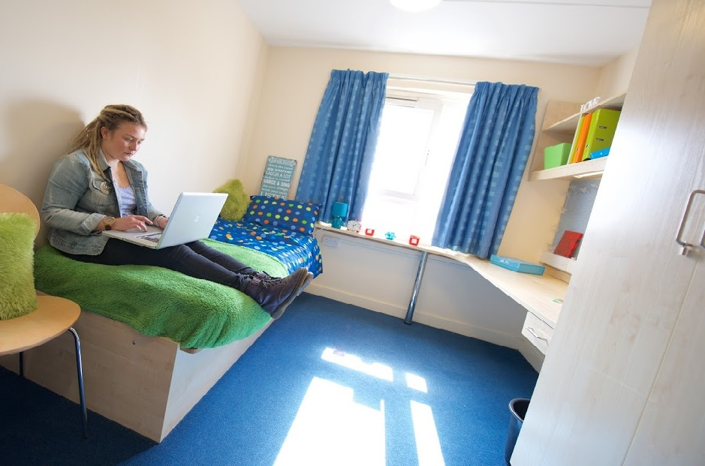
Standard Cluster Flat

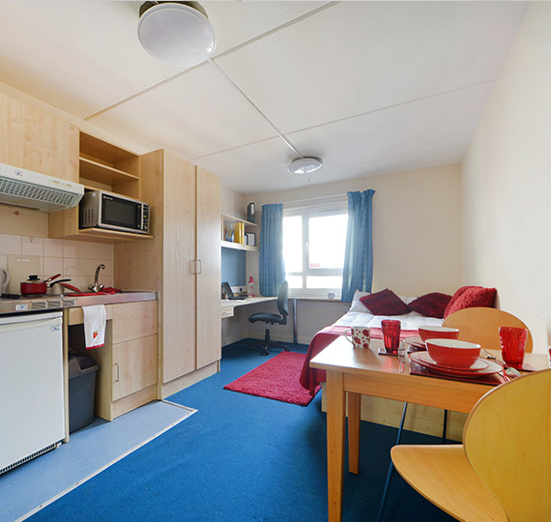

  - Single Studio Flats
A single room but it has its
own kitchenette.

  - Single Studio with 1.2m
  - bed Flats
Same layout as a Studio
Flat but with more space and
a larger bed.

Studio PLUS Flat

What will be in my room?

- All rooms:
  - En suite – toilet, wash basin and shower.
  - Study workstation and chair, bed with under bed storage, wardrobe with hanging space and shelves, bookshelves, pin board and plenty of electrical sockets.
  - Access to high speed internet in your room.
  - Connection to central fire alarm system.

- Standard Cluster and Cluster PLUS Flats:
  - Kitchen/diner includes dining table and chairs, fridge, freezer, oven, grill and hob, extractor hood, microwave, kettle, toaster, iron/ironing board, vacuum cleaner, plenty of storage space.

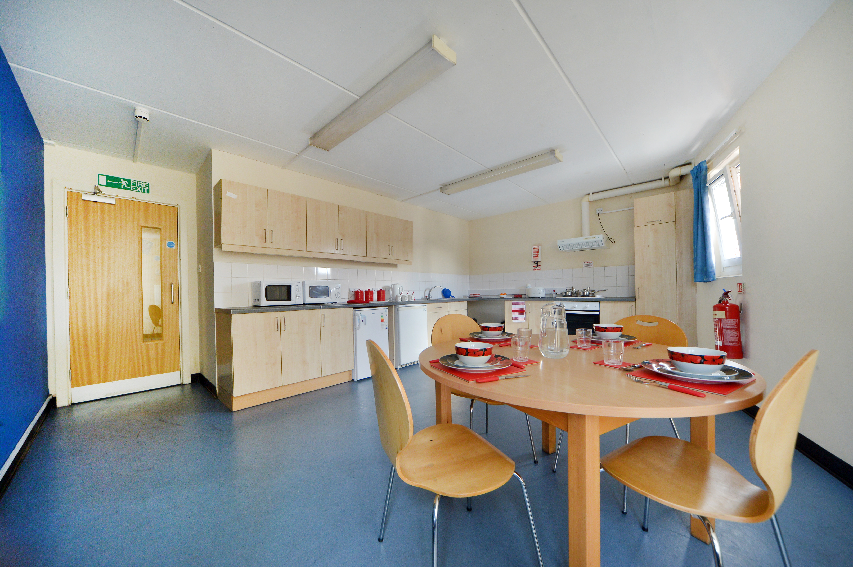
Standard Cluster & Standard Cluster PLUS kitchen/diner

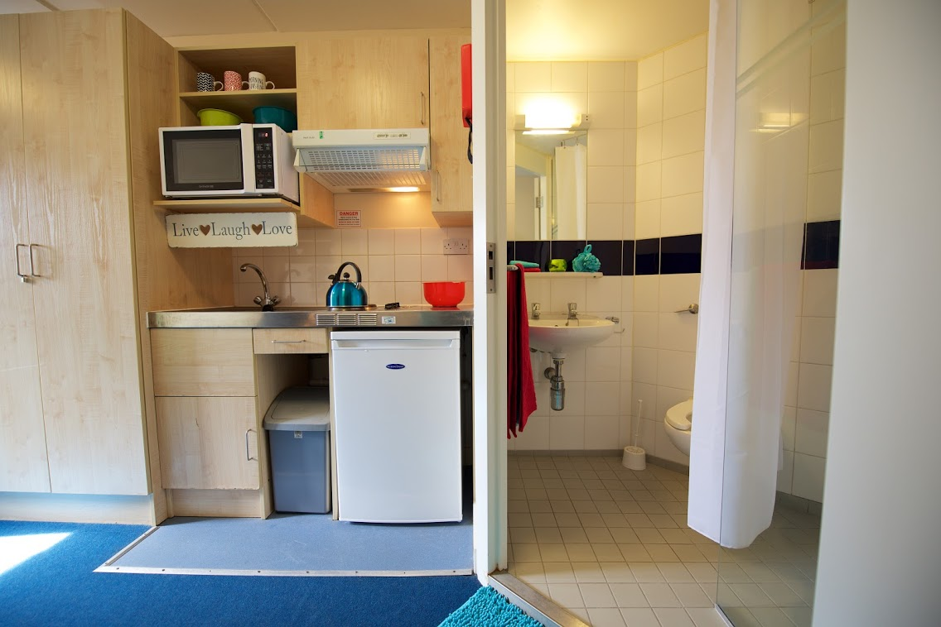
- Single Studio Flat and Single Studio with 1.2m bed Flat:
  - Kitchenette includes stainless steel sink, shelving, electric hotplates, refrigerator, microwave, table and two chairs.

Studio Flat kitchenette and bathroom

Are there any rooms accessible to disabled people?
- We have a limited number of Studio Flats that have been specifically designed for wheelchair users. If you would like to be considered for a Disabled Studio Flat, you should make this clear on your application form. If you require any further information about these rooms and/or general disability access at McMillan Student Village, please email studenthalls@trinitylaban.ac.uk for details.

What are the prices of the rooms?

Standard Cluster | £217.66
Cluster PLUS | £221.78
Standard Studio | £283.57
Single Studio with1.2m bed | £296.54



What is the length of my contract?
- You will be issued a 44 week contract which runs from 7th September 2024 until 12th July 2025. This includes the Christmas and Easter vacations, so you will not need to move your belongings out of your room at the end of each term.

What is included in my rent?

Rent is fully inclusive of electricity and water, and includes free contents insurance of up to £3,000.00 with Endsleigh. Please check with Endsleigh about musical instruments, laptops, internet and mobile phones.

Studying in the Common Room
at McMillan Student Village

What isn’t included in my rent?
- Food, TV licence, laundrette and travel costs are not included in your rent.
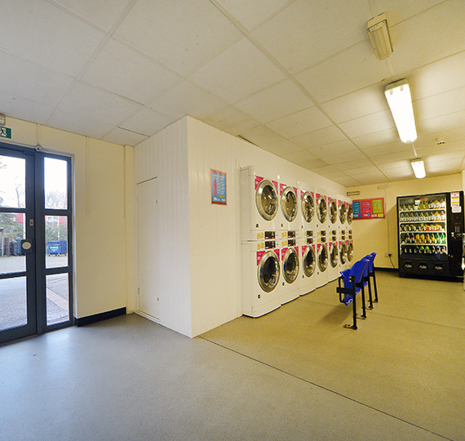
Self-service laundry room
or known in the UK as a Launderette

You will also be responsible for arranging your own TV licence, if you have a TV in your bedroom. If you are in a cluster flat you should note that each bedroom requires its own TV licence. Any TV in the communal areas, i.e. your kitchen/diner, will be covered by a TV licence registered to a bedroom within the flat.



What do I need to bring with me?

You will need to bring your own cooking equipment, e.g. saucepans, crockery, cutlery, etc., as well as cleaning materials, e.g. washing up liquid, dish cloth and tea towels. We suggest that you bring the bare essentials to start with to avoid duplication!

You will also need to bring your own bedding.

Who lives at McMillan Student Village?
McMillan Student Village houses students from several different universities and colleges, including the University of Greenwich, Trinity Laban, Oxford International school of English, Ravensbourne University and Imperial London College.

Are there any practice facilities for musicians?
- McMillan Student Village does not have its own practice rooms, but you are allowed to practise in your own bedroom between 9:00 and 21:00, as long as you don’t disturb your neighbours!
- McMillan Student Village’s great location close to the main Trinity Laban sites means that you are only a few minutes away from practice facilities.

Am I allowed to have people staying over?
- You are allowed to have over-night guests in your room, but you must inform McMillan Student Village Reception. Guests are allowed to stay overnight for a maximum of two nights per week. Camp beds are available for hire from Reception.

Can I bring my car with me?
- Residents of McMillan Student Village are not permitted to bring their cars with them. This is a condition of residency.

Will there be parking available on the day I move in?
- There are no parking restrictions on the roads immediately surrounding McMillan Student Village, although there is no parking available in the actual site. On your moving in day, you are advised to park outside the site and move your belongings into your room as quickly as possible. There will be time restrictions for moving in on the designated moving in days. We will open the Faculty of Dance carpark for residence on the day for a limited time.

How do I apply?

- The application opens on Friday 3rd May. You will need to complete and submit an online application form. The link will be sent to you on Friday 3rd May at 9:30am. The application deadline is 5pm, Friday 24th May 2024. You will also be required to pay a £250 holding deposit at time of application.

- Rooms are allocated on a first come, first served basis by date and time of receipt of your completed application form and payment of your £250 holding deposit and by priority. Priority is given to new students and disabled students with sensory impairments and those who may have difficulties with physical access in private rented accommodation. Current student starting
a new course will be treated as returning students, not new students.

Please note that current students starting a new course will be treated as current students, not new students.
The system for allocating rooms at McMillan Student Village is designed to help those with greater difficulty finding private accommodation, those who may struggle with the upfront cost of private accommodation and those with limited mobility.
If you meet the category for a reserved room, we will need to receive independent evidence that you meet the criteria.
The prioritisation below only applies to students who apply before the deadline. Applications after the deadline are allocated on a first come first served basis.

- Rooms can be reserved for:

- Disabled students with relevant condition (sensory or a physical disability)
- Students who will be under 18 years of age on the date the course starts
- Students with proof of estrangement from their parents (i.e. no contact and support from family or guardian)
- Those leaving local authority care.

- Prioritising those remaining in this order:
- International Students with a home address outside of the UK in their first year of study (on a first come first served basis)

- Undergraduate and Foundation year students in their first year of study who have a home address outside the M25 (on a first come first served basis)

- Postgraduate students in their first year of study who have a home address outside the M25 (on a first come first served basis)

- Undergraduate and Foundation year students in their first year of study who have a home address inside the M25 (on a first come first served basis)

- Postgraduate students in their first year of study who have a home address inside the M25 (on a first come first served basis)

- Coming for a term or a semester?

- Apply as normal but specify which term/semester you wish to stay and we will attempt to match you with someone who will fill the room for the rest of the year. You will still be prioritised according to the above criteria.

- Returning Students:
- Then 4 weeks after that we open to returning students if we have any rooms left.

- You will be notified via email on Friday 14th June with the outcome of your application.

- If you are looking to apply for a room at McMillan Student Village after Friday 24th May please contact studenthalls@trinitylaban.ac.uk for availability.

How can I find out more about McMillan Student Village?

- You can find out more information about McMillan Student Village on their website at https://www.mystudentvillage.com/uk/mcmillanstudentvillage/. This includes information about the campus and surrounding area. Please note that Trinity Laban students should not apply directly online to McMillan Student Village.

- If you have any other questions about McMillan Student Village please contact:
T +44 (0) 20 8305 9342
E studenthalls@trinitylaban.ac.uk

Private Accommodation

- For those needing help and advice about finding private accommodation in London, please contact a member of the Student Services team:
T +44 (0) 20 8305 9350 or +44 (0) 20 8305 4414
E privatehousing@trinitylaban.ac.uk

In the UK public broadcasting is funded by a system of licensing equipment capable of receiving a TV signal. Licensing is not optional if you have a TV receiver installed.

